
Engineering for everyday world

Ace Engineer

Jupyter Notebook

Document

15-Nov-2012 | 01 | Added new features |  |  |  |  | VA | ?? | VA
DATE | REV | DESCRIPTION |  |  |  |  | ORIG | CHK | APPR
DOCUMENT CONTROL NO |  | Project | Type | Area | Client | - | - | Sequence | Revision
 |  |  |  | - | - | - | -

Revision History:

REV | DATE | DESCRIPTION | ORIG | CHK | APPR

Change Log

REV | SECTION | CHANGE DESCRIPTION

Document Holds
Hold | DESCRIPTION

CONTENTS
1 Introduction 4
1.1 Document Purpose 4
2 Installation 4
2.1 Summary 4
2.1.1 Python shells 4
2.1.2 Jupyter Notebook 4
2.2 Anaconda installation 5
3 running jupyter notebook 6
3.1 Anaconda prompt 6
3.2 Python prompt 6
3.3 Shortcut Windows 6
3.3.1 Dashboard 6
3.3.2 Opening notebook environment 7
3.4 .ipynb File 7
3.5 Notebook interface 8
3.5.1 Opening and loading notebook 8
3.5.2 Command mode 8
3.5.3 Edit mode 8
3.6 Major terms 9
3.6.1 Kernel 9
3.6.2 Cells 10
3.6.3 Keyboard shortcuts 11
3.7 Naming notebooks 12
4 Data Analysis 12
4.1 Data Loading 12
4.1.1 Investigating data set 13
4.1.2 Visualizing data set 13
4.2 Sharing notebooks 14
4.3 Exporting notebooks 14
4.3.1 GitHub: 15
4.3.2 Creating a Gist 15
4.3.3 Nbviewer 15

Introduction

Document Purpose
The Jupyter Notebook is an incredibly powerful tool for interactively developing and presenting data science projects. Which integrates code and its output into a single document that combines visualisations, narrative text and mathematical equations. The intuitive workflow promotes iterative and rapid development, making notebooks an increasingly popular choice at the heart of contemporary data science, analytics. This is a web application that runs locally for creating and sharing documents that contain embedded code and execution results.

This document contains the following:
• Initial guidance for Notebook installation and running
• Information to begin
• The key features and version

Installation

Summary
The easiest and simplest way for a beginner to get started with Jupyter Notebook is by installing Anaconda. It is the most widely used Python distribution for data science and comes pre-loaded with all the most popular libraries and tools. As well as Jupyter, some of the biggest Python libraries wrapped up in Anaconda include NumPy, pandas and Matplotlib.

Python shells
IDLE comes with every Python distribution and is a useful tool for everyday programming. Its editor provides syntax highlighting.
There are two reasons that might want to use another Python shell, for example:

While working with the Python prompt, one would like auto-completion of variable names, filenames and commands. In that case IPython is the tool of choice. IPython does not provide an editor, but it can carry on using the IDLE editor to edit files, or any other editor you like.
IPython provides a number of nice features for the more experienced Python programmer, including convenient profiling of code
(See http://ipython.scipy.org).

Jupyter Notebook
The Jupyter Notebook (formerly IPython Notebook) allows one to execute, store, load, re-execute a sequence of Python commands, and to include explanatory text, images and other media in between.

This is a recent and exciting development that has the potential to develop into a tool of great significance, for example for

- Documenting calculations and data processing
- support learning and teaching of Python itself
- statistical methods
- general data post-processing
- documentation new code
- automatic regression testing by re-running IPython notebook and comparing stored output with computed output

Jupyter Notebook (http://jupyter-notebook.readthedocs.io/en/latest/).
IPython (http://ipython.org).

Anaconda installation
The installation of Anaconda can be found below:
https://anaconda.org/anaconda/python
https://conda.io/docs/user-guide/install/windows.html
https://medium.com/@GalarnykMichael/install-python-on-windows-anaconda-c63c7c3d1444/

The key Anaconda features are summarized below:
- Jupyter QT Console: Advanced in-line processing to help write comments, visualize plots as you code along.
- Interactive console for programming
- Great for starters to explore
- A great tool when teaching any concept in detail to audience
- The pages/program can also be shared in cloud for demonstration & easy execution
- Anaconda Navigator helps easy management of modules. It give access to administrative actions such as update, downgrade or remove modules that are incompatible.
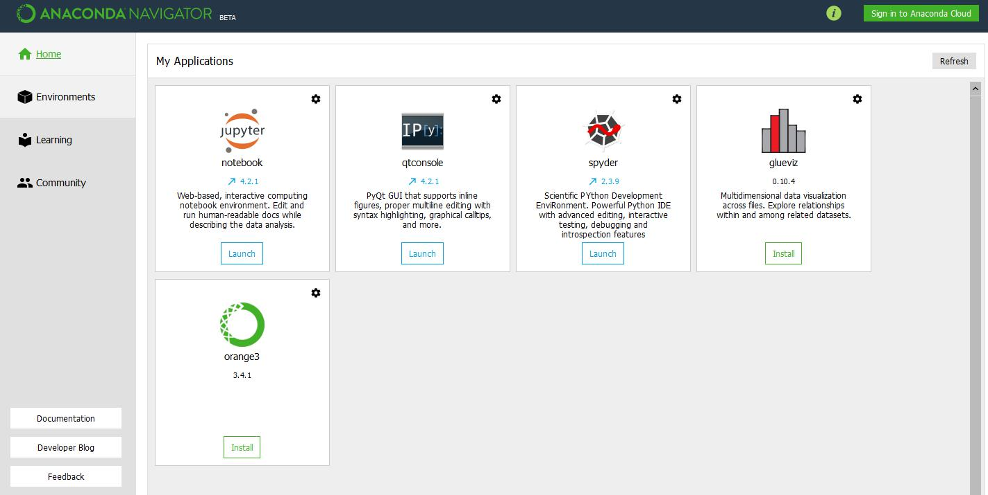

From anaconda click on environments and from that one download Jupyter notebook.

running jupyter notebook

Anaconda prompt
Open anaconda prompt and then type Jupyter notebook

Python prompt
Open python prompt and type pip install Jupyter notebook

Shortcut Windows
On Windows, you can run Jupyter via the shortcut Anaconda adds to your start menu, which will open a new tab in your default web browser that should look something like the following screenshot.

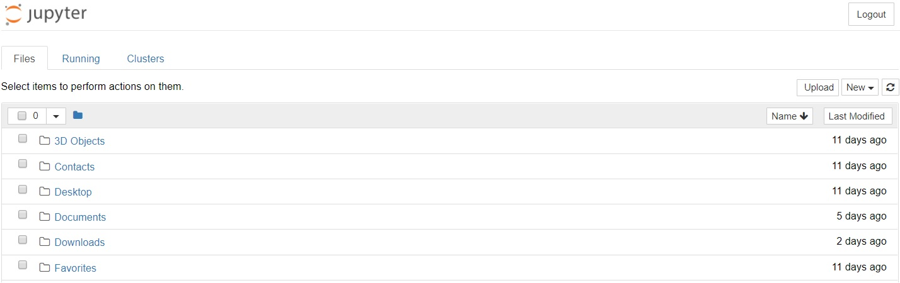

This is the Notebook Dashboard, specifically designed for managing your Jupyter Notebooks. Think of it as the Launchpad for exploring, editing and creating your notebooks.

Dashboard
The dashboard uses and importance:
- It will give access only to the files and sub-folders contained within Jupyter’s start-up directory
- The start-up directory can be changed. It is also possible to start the dashboard on any system via the command prompt (or terminal on UNIX systems) by entering the command jupyter notebook; in this case, the current working directory will be the start-up directory.
- The astute reader may have noticed that the URL for the dashboard is something like http://localhost:8888/tree. Localhost is not a website, but indicates that the content is being served from your local own computer.
- Jupyter's Notebooks and dashboard are web apps, and Jupyter starts up a local Python server to serve these apps to your web browser, making it essentially platform independent and opening the door to easier sharing on the web.
- The dashboard's interface is mostly self-explanatory
- Click the "New" drop-down button in the top-right and select "Python 3/anaconda” (or the version of your choice).

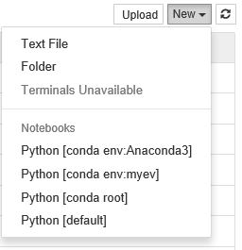

Opening notebook environment
- Click on notebook environment and it open Jupyter Notebook will in new tab.
- Each notebook uses its own tab because you can open multiple notebooks simultaneously.
- If you switch back to the dashboard, you will see the new file Untitled.ipynb you should see some green colour text that tells you your notebook is running.

.ipynb File
It is a text file that describes the contents of your notebook in a format called JSON. Each cell and its contents, including image attachments that have been converted into strings of text, is listed therein along with some metadata.

You can edit this yourself by selecting "Edit > Edit Notebook Metadata" from the menu bar in the notebook.

You can also view the contents of your notebook files by selecting "Edit" from the controls on the dashboard.

Notebook interface
Now that you have an open notebook in front of you, Jupyter is essentially just an advanced word processor.

Opening and loading notebook
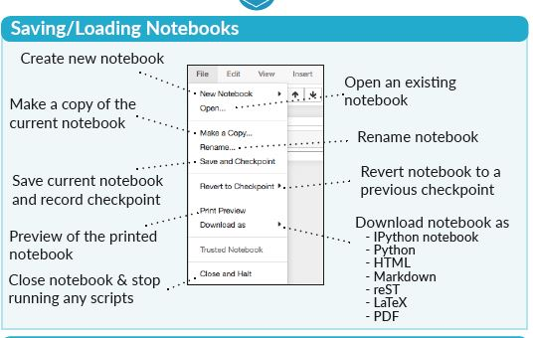

Command mode
Command mode is indicated by a grey cell border with a blue left margin and in command mode, we are able to edit the notebook as a whole, but not type into individual cells. Most importantly, in command mode, the keyboard is mapped to a set of shortcuts that perform notebook and cell actions efficiently.

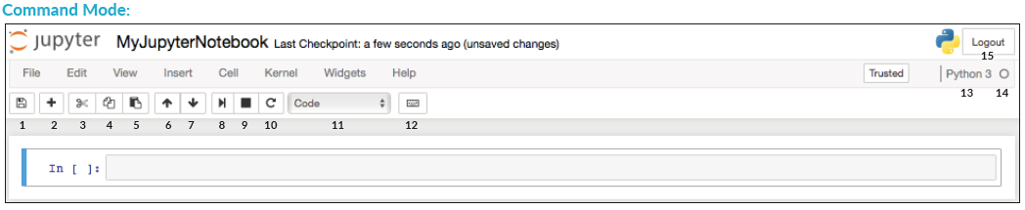

Edit mode
Edit mode is indicated by a green cell border and a prompt showing in the editor area.

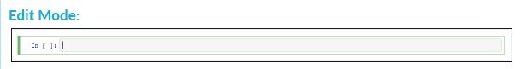

Major terms
There are two fairly prominent terms that should understand before using notebook those are cells and kernels that what makes it more than just a word processor.

Kernel
A kernel is a "computational engine" that executes the code contained in a notebook document.

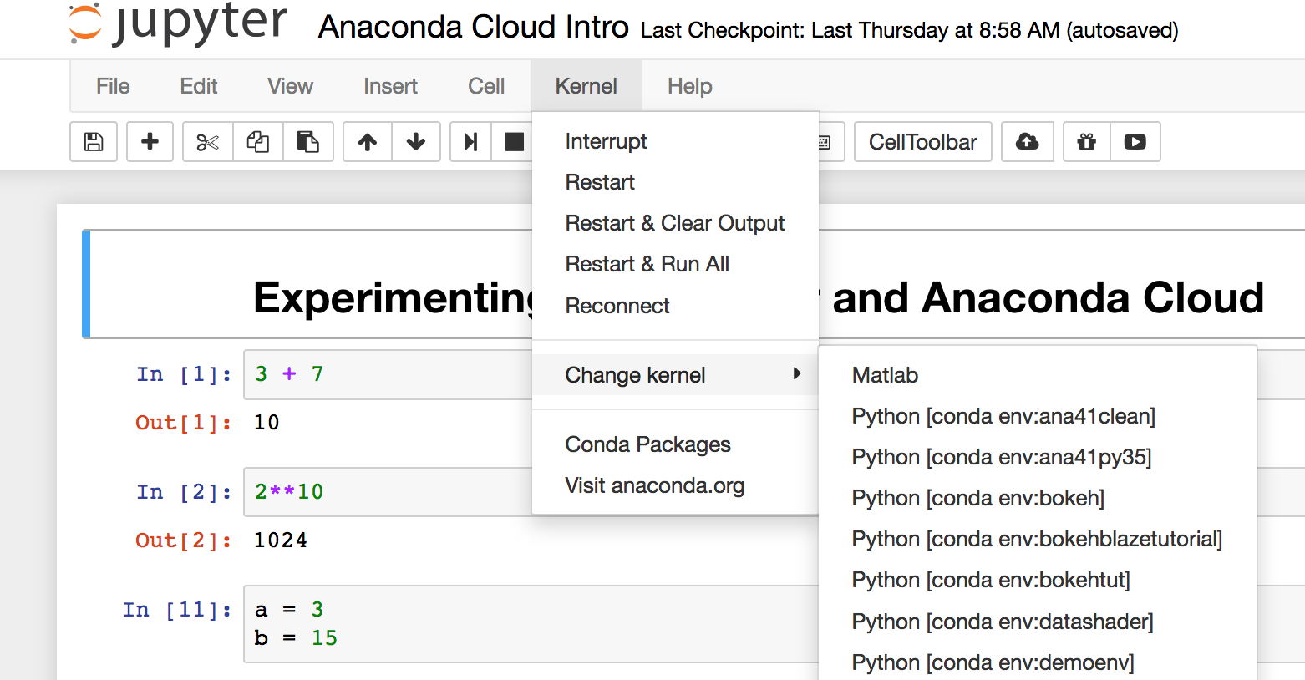

Kernel menu:

- Restart: restarts the kernel, thus clearing all the variables etc. that were defined.
- Restart & Clear Output: restarts the kernel but will also wipe the output displayed below your code cells.
- Restart & Run All: restarts the kernel but will also run all your cells in order from first to last.
- If kernel is stuck on a computation and you wish to stop it, you can choose the Interrupt option.

When you run a code cell, that code is executed within the kernel and any output is returned back to the cell is to be displayed. It persists over time and between cells and it pertains to the document as a whole and not for individual cells.

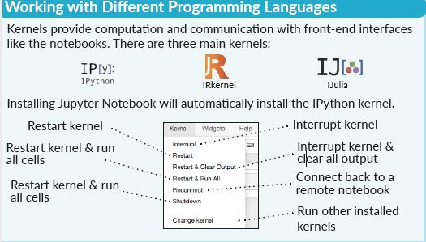
For example, if you import libraries or declare variables in one cell, they will be available in another. In this way, you can think of a notebook document as being somewhat comparable to a script file, except that it is multimedia first, we'll import a Python package and define a function.

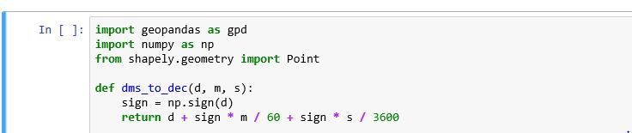

Once we've executed the cell above, we can reference np, geopandas and function that defined in any other cell. The flow in notebook will be from top-to-bottom, but it's common to go back to make changes. In this case, the order of execution stated to the left of each cell

Cells
Cells form the body of a notebook. In the screenshot of a new notebook in the section above, that box with the green outline is an empty cell.

There are two main cell types they are:

A code cell contains code to be executed in the kernel and displays its output below.

A Markdown cell contains formatted text using Markdown and which displays its output in-place when it is run.
The first cell in a new notebook is always a code cell.
For example. Type print ('something') into the cell and click the run button Notebook Run Button in the toolbar above or press Ctrl + Enter. The result should look like this:

When you ran the cell, its output will have been displayed below and the label to its left will have changed from In [3] to In [4].

From the menu bar, click Insert and select Insert Cell Below to create a new code cell

Keyboard shortcuts
One final thing to observe when running cells is that their border turned blue, whereas it was green while editing. There is always one "active" cell highlighted with a border whose colour denotes its current mode, where green means "edit mode" and blue is "command mode."

Keyboard shortcuts are a very popular aspect of the Jupyter environment because they facilitate a speedy cell-based workflow. Many of these are actions you can carry out on the active cell when it's in command mode.

Below, you'll find a list of some of Jupyter's keyboard shortcuts.

- Toggle between edit and command mode with Esc and Enter, respectively.
- Shortcut keys for both command mode and edit mode

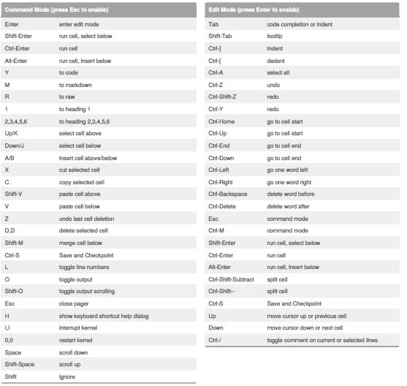

Naming notebooks
Before start writing project, probably want to give it a meaningful name. Perhaps somewhat confusingly, you cannot name or rename your notebooks from the notebook app itself, but must use either the dashboard or your file browser to rename the .ipynb file. We'll head back to the dashboard to rename the file you created earlier, which will have the default notebook file name Untitled.ipynb.

You cannot rename a notebook while it is running, so you've first got to shut it down. The easiest way to do this is to select "File > Close and Halt" from the notebook menu. However, you can also shut down the kernel either by going to "Kernel > Shutdown" from within the notebook app or by selecting the notebook in the dashboard and clicking "Shutdown" (see image below).

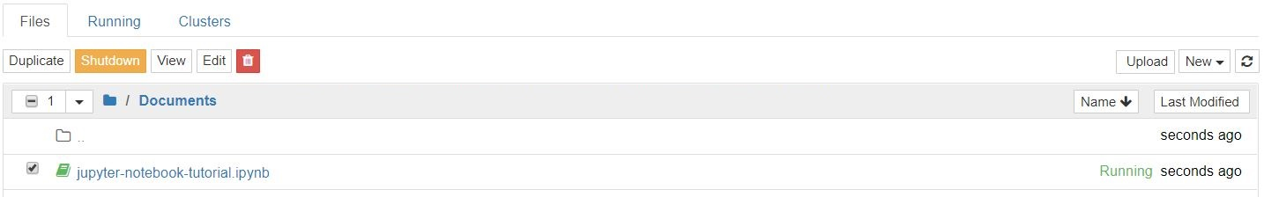

Then select notebook and click "Rename" in the dashboard controls.

Note: closing the notebook tab in browser will not "close" notebook in the way closing a document in a traditional application will. The notebook's kernel will continue to run in the background and needs to be shut down before it is truly "closed" though this is pretty handy if t accidentally closes tab or browser! If the kernel is shut down, close the tab without worrying about whether it is still running or not.

Data Analysis

It is common to start off with a code cell specifically for imports and setup, if choose to add or change anything, simply edit and re-run the cell without causing any side-effects is added advantage.

Data Loading
Loading data by using different modules.

Investigating data set
Notebook is safely saved and loaded with data set df into the most-used pandas data structure, which is called a Data Frame and basically looks like a table.

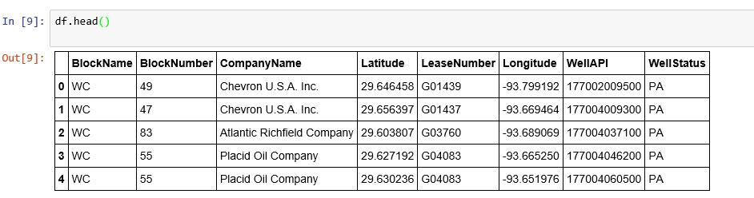

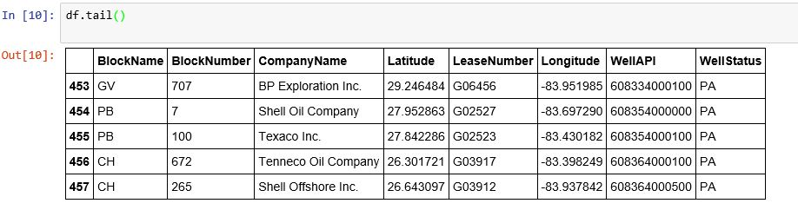

Visualizing data set
As compared with python idle jupyter notebook gives you direct visualization of data in the terminal itself as shown in e.g.,

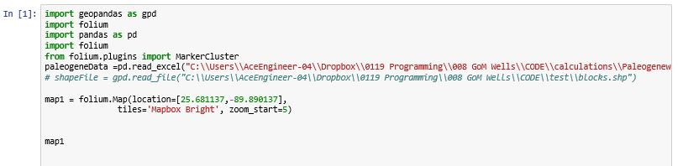

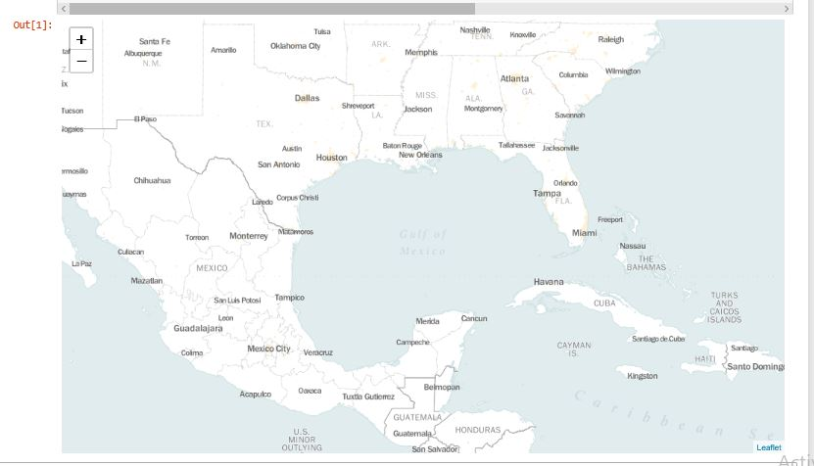

Sharing notebooks
Sharing the notebooks, there are generally two paradigms to be considered while sharing notebook. Most often, individuals share the end-result of their work, means sharing non-interactive, pre-rendered versions of notebooks.

Before sharing some factors to be considered that

A shared notebook will appear exactly in the state it was the state export or save it, including the output of any code cells.

Click "Cell > All Output > Clear"
Click "Kernel > Restart & Run All"

Wait for the code cells to finish executing and check they did so as expected. This will ensure that notebooks don't contain intermediary output, have a stale state, and executed in order at the time of sharing.

Exporting notebooks
Jupyter has built-in support for exporting to HTML and PDF as well as several other formats, which can find from the menu under "File > Download As." If anyone wish to share notebooks with a small private group, this functionality may help, Jupyter Notebooks can be an especially convenient way for them to share their results with their peers.

There are also some immensely popular methods of sharing .ipynb files more directly on the web.

GitHub:
With the number of public notebooks on GitHub exceeding 1.8 million by early 2018, it is surely the most popular independent platform for sharing Jupyter projects with the world. GitHub has integrated support for rendering .ipynb files directly both in repositories and gist’s on its website. GitHub is a code hosting platform for version control and collaboration for repositories created with Git. Users need an account to use their services, but standard accounts are free.

Once having a GitHub account, the easiest way to share a notebook on GitHub doesn't actually require Git at all. Since 2008, GitHub has provided its Gist service for hosting and sharing code snippets, which each get their own repository. To share a notebook using Gist’s:

- Sign in and browse to gist.github.com.
- Open your .ipynb file in a text editor, select all and copy the JSON inside.
- Paste the notebook JSON into the gist.
- Give your Gist a filename, remembering to add .ipynb or this will not work.
- Click either "Create secret gist" or "Create public gist."
- This should look something like the following:

Creating a Gist

If user created a public Gist, user will now be able to share its URL with anyone, and others will be able to fork and clone his work.

Creating own Git repository and sharing this on GitHub hat which helps you to get started on your own.

Nbviewer
Having grown to render hundreds of thousands of notebooks every week by 2015, Nbviewer is the most popular notebook renderer on the web. If user already have somewhere to host Jupyter Notebooks online, be it GitHub or elsewhere, Nbviewer will render thier notebook and provide a shareable URL along with it. Provided as a free service as part of Project Jupyter, it is available at nbviewer.jupyter.org.

Initially developed before GitHub's Jupyter Notebook integration, Nbviewer allows anyone to enter a URL, Gist ID, or GitHub username/repo/file and it will render the notebook as a webpage. A Gist's ID is the unique number at the end of its URL.

For example, the string of characters after the last backslash in https://gist.github.com/username/50896401c23e0bf417e89cd57e89e1de. If you enter a GitHub username or username/repo, you will see a minimal file browser that lets you explore a user's repos and their contents.

The URL Nbviewer displays when displaying a notebook is a constant based on the URL of the notebook it is rendering, so then you can share this with anyone and it will work as long as the original files remain online. Nbviewer doesn't cache files for very long.

